1. Install a docker desktop on your computer.
2. Create a Docker Hub account.

1. Find a Python image that you could use on the docker hub.

1. Now go to the cmd line on your computer and run the following command.

1. Docker image ls

1. Now rename this image to something more useful.



1. Now run a container using this image within the docker

1. Docker ps



1. You will see that docker assigns a random name (id far right) to your loaded image.
2. Rename the Python container.

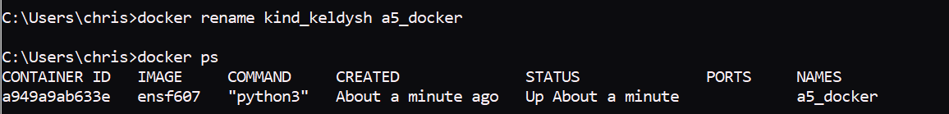

1. Now we want to go into the container.
2. Create folders

1. Now we want to upload our little Python script named testprint.py.
2. Run the command to upload the python script.

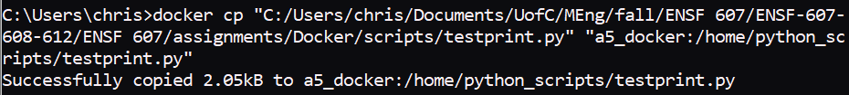

1. Run the command.

